

Introduction To AI
Submitted By : Shamama Syed
Submitted To: Sir Irshad ullah
Registration No: 24JZELE0563
Section: Ai
Semester: 3RD

ASSIGNMENT 1:
- Load the CSV manually using the csv module (not pandas).
- Store the consumption column in a list of floats.
  - Compute:
    - Total consumption
    - Average consumption
    - Maximum and minimum
- Use a list comprehension to convert hourly consumption into kWh.
- Print all results in a clean format

`1

Program

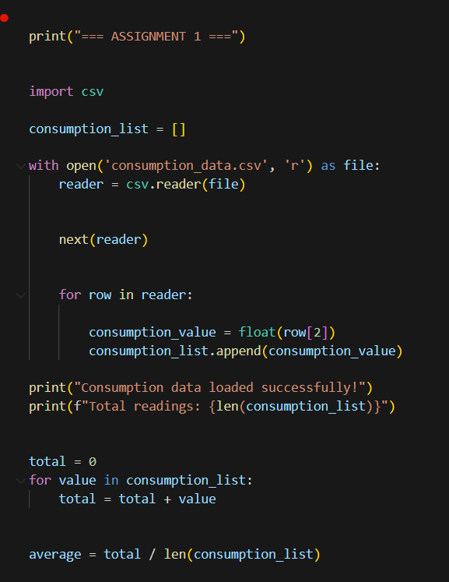

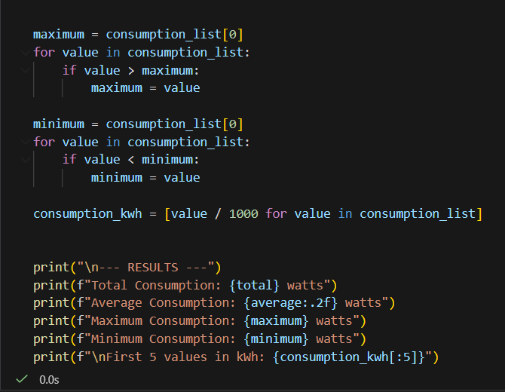
Output:
